Module 8

8.2 Assignment
Course: CSD325 – 340A
Prepared By: Mirach Erkol and James Buzzell
Date of Report: 11/23/2025

Mikey5007/csd-325: csd-325

8.2 Assignment: Flow Chart
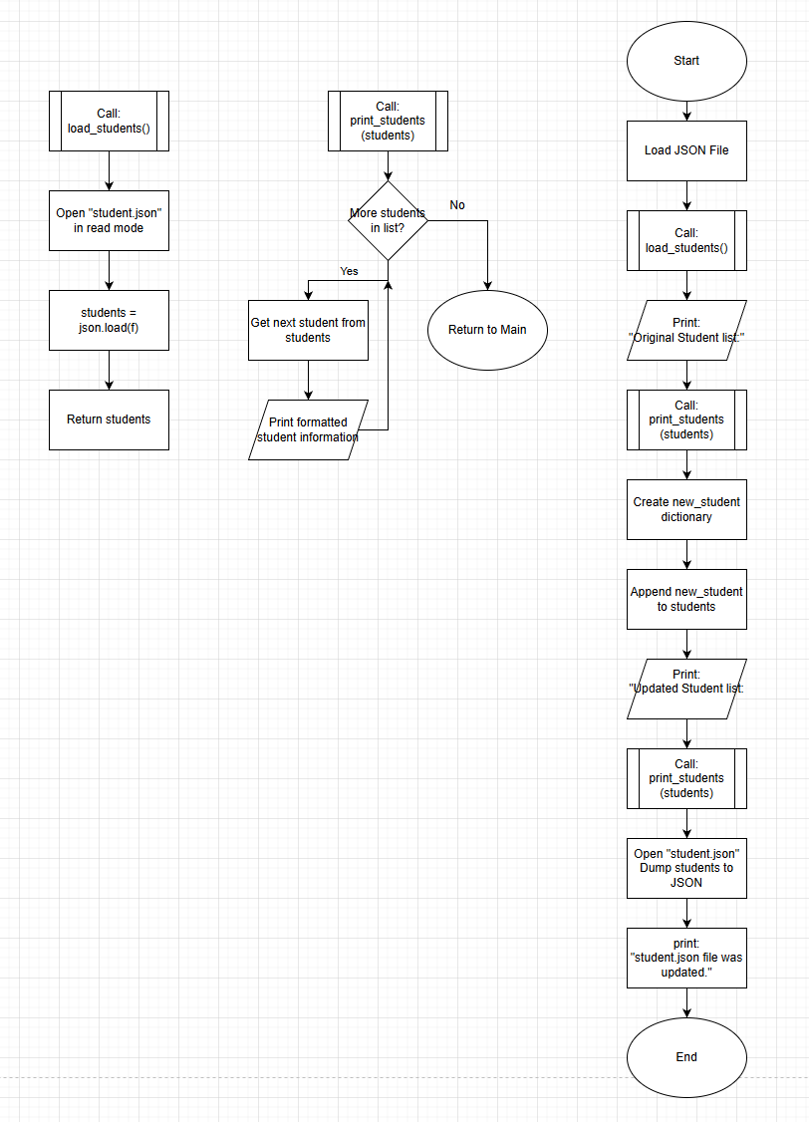

8.2 Assignment: Screenshot of code running and updated Json File
(Note both VS code and Notepad updated automatically without the notification after the script was ran)
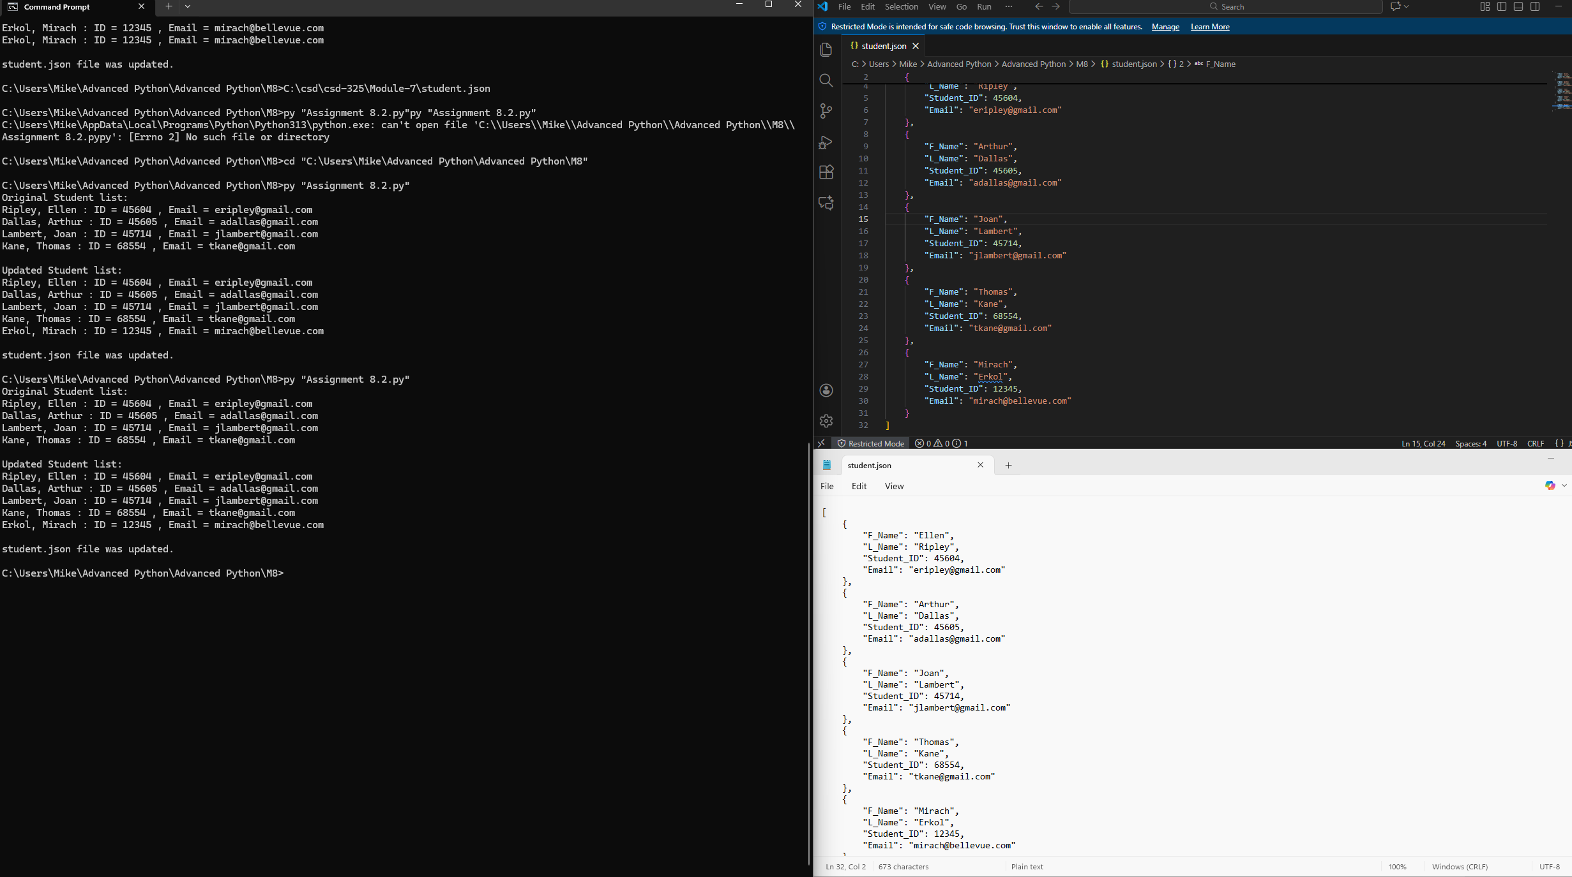

8.2 Assignment: Updated JSON File

[
{
"F_Name": "Ellen",
"L_Name": "Ripley",
"Student_ID": 45604,
"Email": "eripley@gmail.com"
},
{
"F_Name": "Arthur",
"L_Name": "Dallas",
"Student_ID": 45605,
"Email": "adallas@gmail.com"
},
{
"F_Name": "Joan",
"L_Name": "Lambert",
"Student_ID": 45714,
"Email": "jlambert@gmail.com"
},
{
"F_Name": "Thomas",
"L_Name": "Kane",
"Student_ID": 68554,
"Email": "tkane@gmail.com"
},
{
"F_Name": "Mirach",
"L_Name": "Erkol",
"Student_ID": 12345,
"Email": "mirach@bellevue.com"
}
]

